LAB 02

Q1. Design the student bio-data form using button, label, textbox, radio button, table and

checkbox using CSS.

<!DOCTYPE html>

<html lang="en">

<head>

<meta charset="UTF-8">

<meta name="viewport" content="width=device-width, initial-scale=1.0">

<title>Bio Data</title>

<style>

\* {

margin: 0;

padding: 0;

box-sizing: border-box;

}

body {

font-family: Arial, sans-serif;

background-color: #f2f4f7;

color: #333;

}

.main {

display: flex;

justify-content: center;

align-items: center;

min-height: 100vh;

background-color: #f0f8ff;

}

.container {

width: 100%;

max-width: 800px;

background-color: #fff;

padding: 2rem;

border-radius: 0.8rem;

box-shadow: 0 4px 8px rgba(0, 0, 0, 0.1);

border: 1px solid #ddd;

}

h2 {

font-size: 2rem;

text-align: center;

margin-bottom: 1rem;

}

.item {

margin-bottom: 1.2rem;

}

.input, .text, textarea {

width: 100%;

padding: 0.8rem;

font-size: 1rem;

border: 1px solid #ccc;

border-radius: 0.3rem;

}

.text, textarea {

height: 30px;

}

label {

font-size: 1.2rem;

font-weight: 500;

margin-bottom: 0.5rem;

display: inline-block;

}

.radio-group, .checkbox-group {

display: flex;

gap: 1rem;

flex-wrap: wrap;

}

.radio-group input, .checkbox-group input {

margin-right: 0.5rem;

}

textarea {

resize: vertical;

min-height: 80px;

}

table {

width: 100%;

border-collapse: collapse;

margin-bottom: 1rem;

}

table, th, td {

border: 1px solid #ccc;

}

th, td {

padding: 0.8rem;

text-align: left;

}

th {

background-color: #f5f5f5;

}

.submit {

background-color: #007bff;

color: white;

border: none;

padding: 0.8rem 2rem;

font-size: 1.2rem;

border-radius: 0.3rem;

transition: background-color 0.3s ease;

}

.submit:hover {

background-color: #0056b3;

}

</style>

</head>

<body>

<div class="main">

<div class="container">

<form>

<div class="item">

<h2>Student Bio-Data Form</h2>

</div>

<div class="item">

<label for="name">Name</label><br>

<input class="text" type="text" name="name" id="name">

</div>

<div class="item">

<label for="email">Email</label><br>

<input class="text" type="email" name="email" id="email">

</div>

<div class="item">

<label for="phone">Phone</label><br>

<input class="text" type="number" name="phone" id="phone">

</div>

<div class="item">

<label for="college">College</label><br>

<input class="text" type="text" name="college" id="college">

</div>

<div class="item">

<label>Gender</label><br>

<div class="radio-group">

<input type="radio" name="gender" id="gender1" value="male"> Male

<input type="radio" name="gender" id="gender2" value="female"> Female

<input type="radio" name="gender" id="gender3" value="others"> Others

</div>

</div>

<div class="item">

<label>Skills</label><br>

<div class="checkbox-group">

<input type="checkbox" name="skills" id="skills1"> Web Development

<input type="checkbox" name="skills" id="skills2"> Machine Learning

<input type="checkbox" name="skills" id="skills3"> Data Analysis

</div>

</div>

<div class="item">

<label for="bio">Bio</label><br>

<textarea class="text" name="bio" id="bio"></textarea>

</div>

<div class="item">

<label for="subjects">Subjects</label><br>

<table>

<thead>

<tr>

<th>Subject Name</th>

<th>Score</th>

</tr>

</thead>

<tbody>

<tr>

<td><input type="text" name="subject1" class="input" placeholder="Enter subject"></td>

<td><input type="number" name="score1" class="input" placeholder="Enter score"></td>

</tr>

<tr>

<td><input type="text" name="subject2" class="input" placeholder="Enter subject"></td>

<td><input type="number" name="score2" class="input" placeholder="Enter score"></td>

</tr>

<tr>

<td><input type="text" name="subject3" class="input" placeholder="Enter subject"></td>

<td><input type="number" name="score3" class="input" placeholder="Enter score"></td>

</tr>

</tbody>

</table>

</div>

<div class="item">

<input class="submit" id="submit" type="submit" value="Submit">

</div>

</form>

</div>

</div>

</body>

</html>

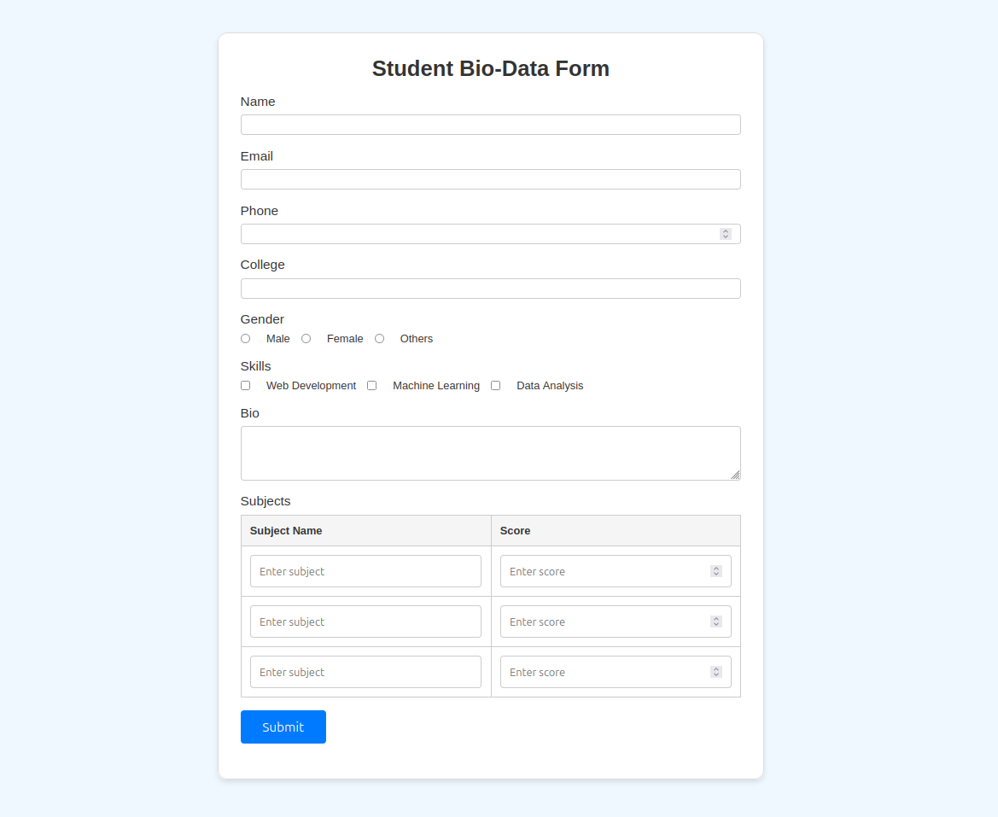

Q3. Create a web page using bootstrap as mentioned. Divide the page in to 2 parts top and

bottom, then divide the bottom into 3 parts and design each top and bottom part using

different input groups, input, badges, buttons and button groups. Make the design more

attractive using bootstrap.  
  
<!DOCTYPE html>

<html lang="en">

<head>

<meta charset="UTF-8">

<meta name="viewport" content="width=device-width, initial-scale=1.0">

<title>Responsive Bootstrap Page</title>

<link href="https://cdn.jsdelivr.net/npm/bootstrap@5.3.3/dist/css/bootstrap.min.css" rel="stylesheet" integrity="sha384-QWTKZyjpPEjISv5WaRU9OFeRpok6YctnYmDr5pNlyT2bRjXh0JMhjY6hW+ALEwIH" crossorigin="anonymous">

<style>

body {

background-color: #f8f9fa;

}

.top {

background-color: #343a40;

width: 100%;

border-radius: 0.5rem;

overflow: hidden;

margin-bottom: 3rem;

}

.carousel-inner img {

object-fit: cover;

height: 400px;

}

.bottom {

display: flex;

flex-wrap: wrap;

gap: 2rem;

justify-content: center;

align-items: center;

width: 100%;

padding: 2rem;

}

.item {

display: flex;

justify-content: center;

align-items: center;

flex-direction: column;

}

.button-group {

display: flex;

gap: 1rem;

margin-bottom: 2rem;

}

.card {

width: 18rem;

box-shadow: 0 4px 8px rgba(0, 0, 0, 0.1);

border-radius: 0.5rem;

}

.card-img-top {

object-fit: cover;

height: 200px;

border-radius: 0.5rem 0.5rem 0 0;

}

.card-body {

padding: 1.5rem;

}

.card-title {

font-size: 1.25rem;

font-weight: 600;

}

.card-text {

font-size: 1rem;

color: #6c757d;

}

.badge {

margin-top: 1.5rem;

}

.btn {

border-radius: 0.5rem;

padding: 0.8rem 1.5rem;

}

.btn-primary:hover, .btn-secondary:hover, .btn-success:hover {

transform: translateY(-2px);

transition: transform 0.2s ease;

}

.card:hover {

transform: translateY(-5px);

transition: transform 0.2s ease;

}

</style>

</head>

<body>

<div class="container">

<div class="top">

<div id="carouselExampleAutoplaying" class="carousel slide" data-bs-ride="carousel">

<div class="carousel-inner">

<div class="carousel-item active">

<img src="image.jpg" class="d-block w-100" alt="Image 1">

</div>

<div class="carousel-item">

<img src="image.jpg" class="d-block w-100" alt="Image 2">

</div>

<div class="carousel-item">

<img src="image.jpg" class="d-block w-100" alt="Image 3">

</div>

</div>

<button class="carousel-control-prev" type="button" data-bs-target="#carouselExampleAutoplaying" data-bs-slide="prev">

<span class="carousel-control-prev-icon" aria-hidden="true"></span>

<span class="visually-hidden">Previous</span>

</button>

<button class="carousel-control-next" type="button" data-bs-target="#carouselExampleAutoplaying" data-bs-slide="next">

<span class="carousel-control-next-icon" aria-hidden="true"></span>

<span class="visually-hidden">Next</span>

</button>

</div>

</div>

<div class="bottom">

<div class="item">

<h4>Input Group & Badge</h4>

<div class="input-group mb-3">

<span class="input-group-text" id="basic-addon1">@</span>

<input type="text" class="form-control" placeholder="Username" aria-label="Username" aria-describedby="basic-addon1">

</div>

<div class="input-group mb-3">

<span class="input-group-text" id="basic-addon2">Email</span>

<input type="email" class="form-control" placeholder="Email Address" aria-label="Email" aria-describedby="basic-addon2">

</div>

<span class="badge bg-success">New</span>

</div>

<div class="item">

<h4>Button Group</h4>

<div class="button-group">

<button type="button" class="btn btn-primary">Primary</button>

<button type="button" class="btn btn-secondary">Secondary</button>

<button type="button" class="btn btn-success">Success</button>

</div>

<button type="button" class="btn btn-warning">Warning Button</button>

</div>

<div class="item">

<h4>Card Example</h4>

<div class="card">

<img src="https://via.placeholder.com/200x200" class="card-img-top" alt="Card Image">

<div class="card-body">

<h5 class="card-title">Card Title</h5>

<p class="card-text">This is an example of a card with an image and some text to make the design more appealing.</p>

<a href="#" class="btn btn-primary">Learn More</a>

</div>

</div>

</div>

</div>

</div>

<script src="https://cdn.jsdelivr.net/npm/bootstrap@5.3.3/dist/js/bootstrap.bundle.min.js" integrity="sha384-YvpcrYf0tY3lHB60NNkmXc5s9fDVZLESaAA55NDzOxhy9GkcIdslK1eN7N6jIeHz" crossorigin="anonymous"></script>

</body>

</html>

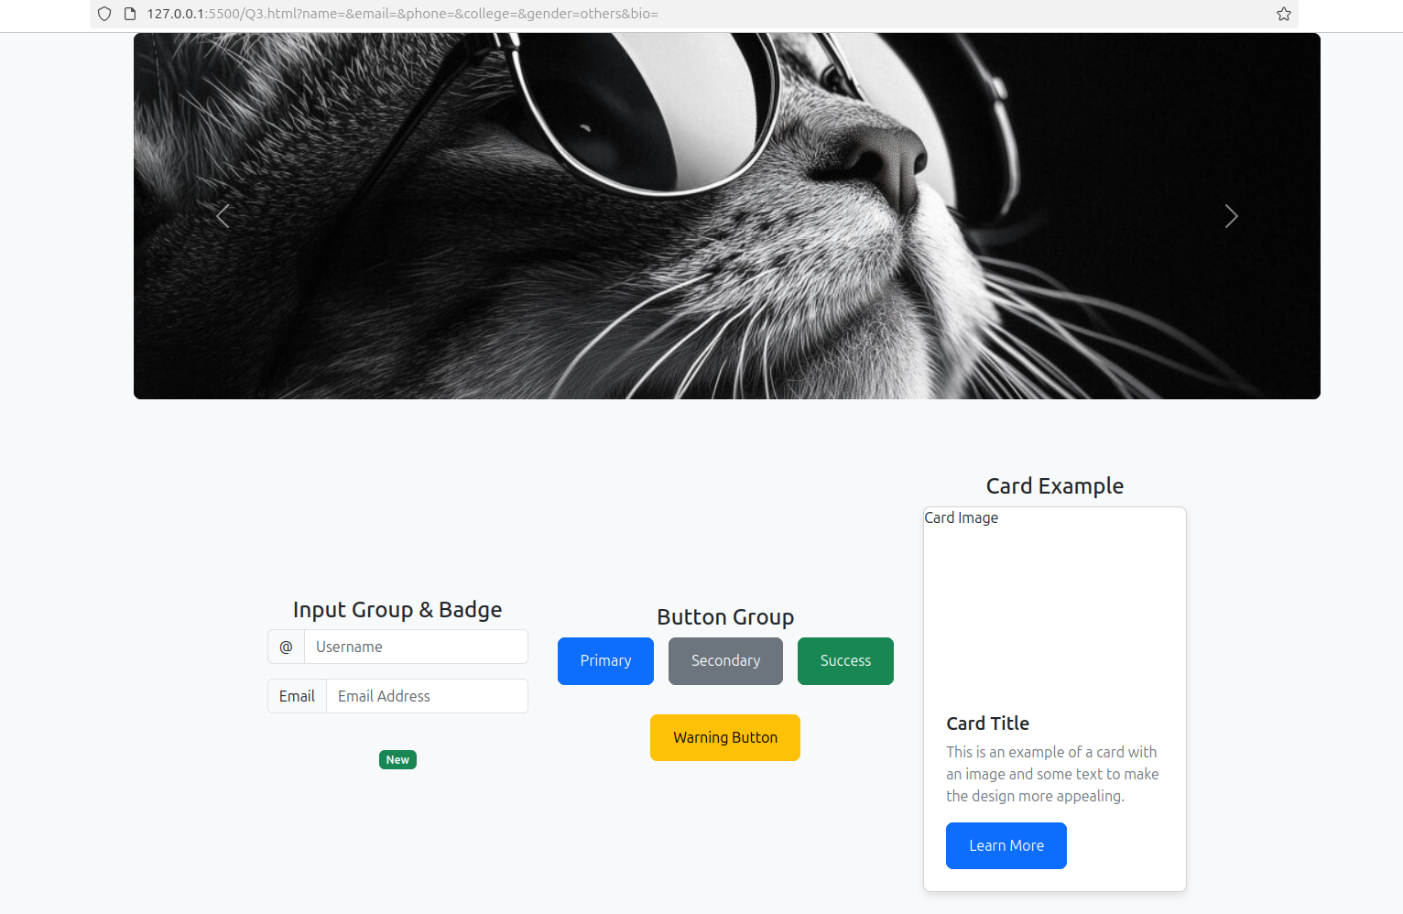  
  
  
Q4. Design your class timetable using bootstrap table and carousel.

<!DOCTYPE html>

<html lang="en">

<head>

<meta charset="UTF-8">

<meta name="viewport" content="width=device-width, initial-scale=1.0">

<title>Class Timetable</title>

<link href="https://cdn.jsdelivr.net/npm/bootstrap@5.3.3/dist/css/bootstrap.min.css" rel="stylesheet" integrity="sha384-QWTKZyjpPEjISv5WaRU9OFeRpok6YctnYmDr5pNlyT2bRjXh0JMhjY6hW+ALEwIH" crossorigin="anonymous">

<style>

body {

background-color: #f8f9fa;

}

.container {

margin-top: 3rem;

}

.carousel-inner {

max-height: 400px;

}

table {

margin-top: 1.5rem;

width: 100%;

}

.table th, .table td {

text-align: center;

vertical-align: middle;

}

.carousel-item img {

object-fit: cover;

height: 100%;

width: 100%;

}

.table-header {

background-color: #007bff;

color: white;

}

.carousel-caption {

position: absolute;

bottom: 20px;

left: 50%;

transform: translateX(-50%);

color: white;

}

.carousel-control-prev-icon, .carousel-control-next-icon {

filter: invert(1);

}

</style>

</head>

<body>

<div class="container">

<div id="timetableCarousel" class="carousel slide" data-bs-ride="carousel">

<div class="carousel-inner">

<div class="carousel-item active">

<div class="carousel-caption">

<h3>Monday</h3>

</div>

<table class="table table-bordered table-hover">

<thead class="table-header">

<tr>

<th>Time</th>

<th>Subject</th>

<th>Instructor</th>

</tr>

</thead>

<tbody>

<tr>

<td>8:00 AM - 9:00 AM</td>

<td>Math 101</td>

<td>Dr. Smith</td>

</tr>

<tr>

<td>9:15 AM - 10:15 AM</td>

<td>Physics 102</td>

<td>Prof. Johnson</td>

</tr>

<tr>

<td>10:30 AM - 11:30 AM</td>

<td>Chemistry 103</td>

<td>Dr. Lee</td>

</tr>

</tbody>

</table>

</div>

<div class="carousel-item">

<div class="carousel-caption">

<h3>Tuesday</h3>

</div>

<table class="table table-bordered table-hover">

<thead class="table-header">

<tr>

<th>Time</th>

<th>Subject</th>

<th>Instructor</th>

</tr>

</thead>

<tbody>

<tr>

<td>8:00 AM - 9:00 AM</td>

<td>English Literature</td>

<td>Ms. Davis</td>

</tr>

<tr>

<td>9:15 AM - 10:15 AM</td>

<td>History 201</td>

<td>Dr. Brown</td>

</tr>

<tr>

<td>10:30 AM - 11:30 AM</td>

<td>Biology 104</td>

<td>Prof. Green</td>

</tr>

</tbody>

</table>

</div>

<div class="carousel-item">

<div class="carousel-caption">

<h3>Wednesday</h3>

</div>

<table class="table table-bordered table-hover">

<thead class="table-header">

<tr>

<th>Time</th>

<th>Subject</th>

<th>Instructor</th>

</tr>

</thead>

<tbody>

<tr>

<td>8:00 AM - 9:00 AM</td>

<td>Computer Science</td>

<td>Dr. Wilson</td>

</tr>

<tr>

<td>9:15 AM - 10:15 AM</td>

<td>Mathematics</td>

<td>Prof. Harris</td>

</tr>

<tr>

<td>10:30 AM - 11:30 AM</td>

<td>Art 105</td>

<td>Ms. Clark</td>

</tr>

</tbody>

</table>

</div>

<div class="carousel-item">

<div class="carousel-caption">

<h3>Thursday</h3>

</div>

<table class="table table-bordered table-hover">

<thead class="table-header">

<tr>

<th>Time</th>

<th>Subject</th>

<th>Instructor</th>

</tr>

</thead>

<tbody>

<tr>

<td>8:00 AM - 9:00 AM</td>

<td>Psychology</td>

<td>Dr. Adams</td>

</tr>

<tr>

<td>9:15 AM - 10:15 AM</td>

<td>Sociology</td>

<td>Prof. Taylor</td>

</tr>

<tr>

<td>10:30 AM - 11:30 AM</td>

<td>Physics 102</td>

<td>Prof. Johnson</td>

</tr>

</tbody>

</table>

</div>

<div class="carousel-item">

<div class="carousel-caption">

<h3>Friday</h3>

</div>

<table class="table table-bordered table-hover">

<thead class="table-header">

<tr>

<th>Time</th>

<th>Subject</th>

<th>Instructor</th>

</tr>

</thead>

<tbody>

<tr>

<td>8:00 AM - 9:00 AM</td>

<td>Philosophy 101</td>

<td>Dr. Robinson</td>

</tr>

<tr>

<td>9:15 AM - 10:15 AM</td>

<td>Geography</td>

<td>Prof. King</td>

</tr>

<tr>

<td>10:30 AM - 11:30 AM</td>

<td>Literature</td>

<td>Ms. Edwards</td>

</tr>

</tbody>

</table>

</div>

</div>

<button class="carousel-control-prev" type="button" data-bs-target="#timetableCarousel" data-bs-slide="prev">

<span class="carousel-control-prev-icon" aria-hidden="true"></span>

<span class="visually-hidden">Previous</span>

</button>

<button class="carousel-control-next" type="button" data-bs-target="#timetableCarousel" data-bs-slide="next">

<span class="carousel-control-next-icon" aria-hidden="true"></span>

<span class="visually-hidden">Next</span>

</button>

</div>

</div>

<script src="https://cdn.jsdelivr.net/npm/bootstrap@5.3.3/dist/js/bootstrap.bundle.min.js" integrity="sha384-YvpcrYf0tY3lHB60NNkmXc5s9fDVZLESaAA55NDzOxhy9GkcIdslK1eN7N6jIeHz" crossorigin="anonymous"></script>

</body>

</html>

